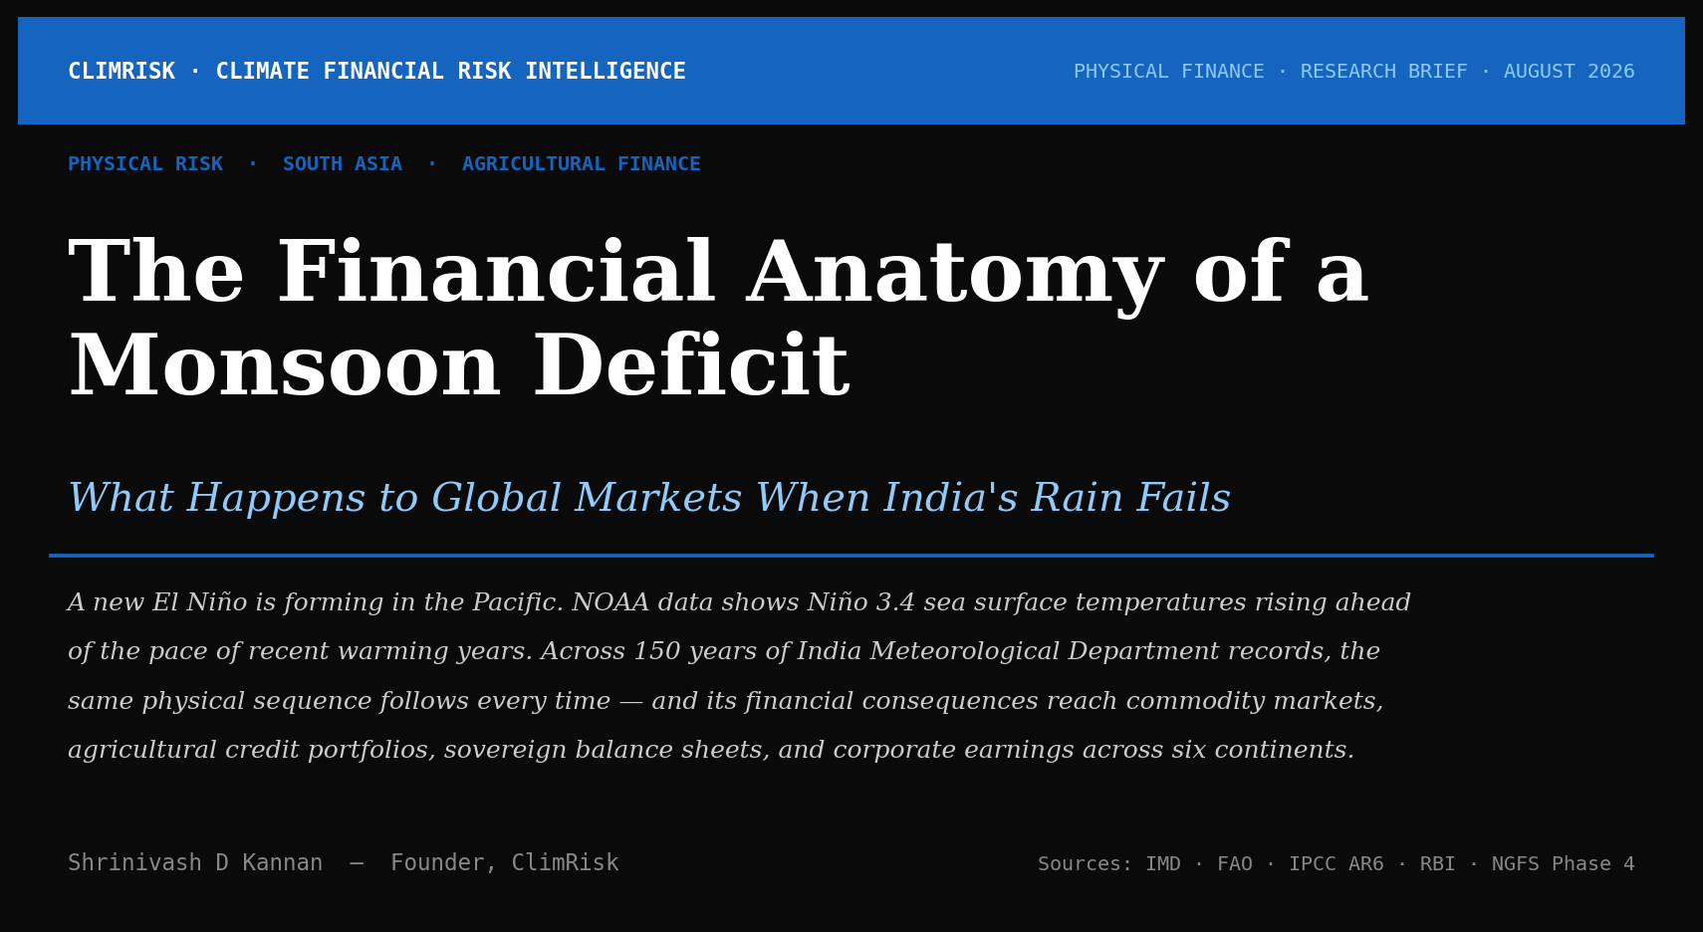
The India Meteorological Department has measured monsoon rainfall since 1871. Across 150 years of instrumental records, the correlation between El Niño events and below-normal monsoon rainfall holds with a consistency that climate scientists describe as one of the most reliable teleconnections in the global climate system. [IMD 1871–2024 Series]
A new El Niño is forming now. Sea surface temperatures in the Niño 3.4 region — the central equatorial Pacific index that defines El Niño events — are rising ahead of the pace recorded in other recent warming years. [NOAA ENSO Monitoring] The trajectory points toward a significant event by late 2026 and into 2027.
This piece maps what that means for India's monsoon, and what India's monsoon means for commodity markets, agricultural credit, sovereign fiscal stress, corporate earnings, hydropower, and emerging market debt.

What the Indian Summer Monsoon Actually Is
The southwest monsoon arrives over Kerala in early June, advances northward through July, and withdraws by late September. Four months. That window delivers the rainfall that determines whether India's agricultural year succeeds or fails. The IMD's Long Period Average — computed over the 1971 to 2020 reference period — is 87 centimetres for the full season. [IMD LPA 1971–2020]
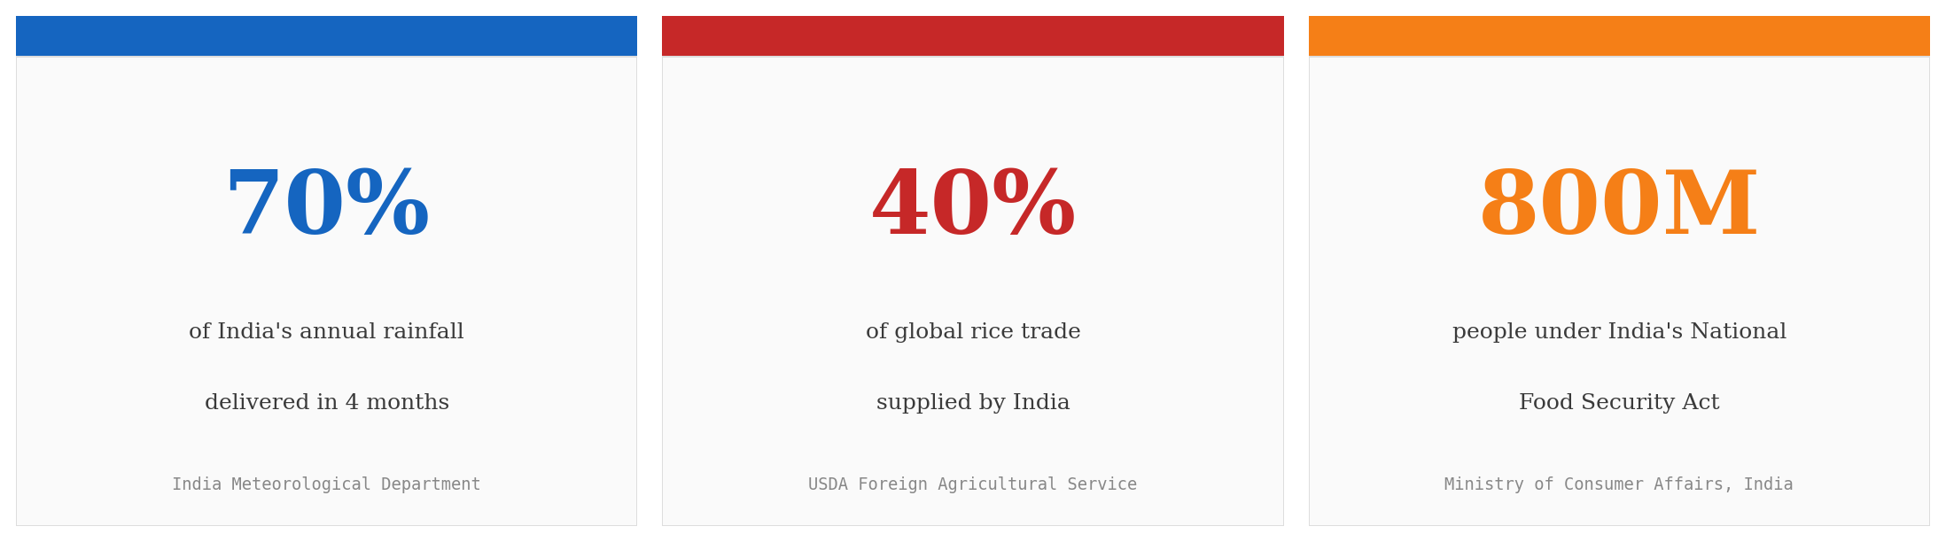
Agriculture accounts for approximately 15 percent of India's GDP [MoSPI India] — but it employs close to 50 percent of the workforce and underpins the rural purchasing power that drives demand across consumer staples, tractors, motorcycles, and financial services. When the monsoon underdelivers, the economic transmission is broad and deep.

The Physical Mechanism: How El Niño Breaks the Monsoon
The Indian summer monsoon is driven by the temperature differential between the rapidly warming Asian landmass and the cooler Indian Ocean. As land heats faster than sea, it draws moisture-laden ocean air inland — creating the sustained low-pressure system that generates rainfall across the subcontinent.
El Niño disrupts this by weakening the Walker Circulation — the large-scale atmospheric loop that normally carries warm, moist air westward across the tropical Pacific, drives convection over the Indian Ocean, and reinforces the pressure gradient that pulls the monsoon inland. [IPCC AR6 WGI Ch.3] When Pacific SST anomalies rise, convection migrates eastward, the Indian Ocean loses its moisture driver, and the monsoon weakens.
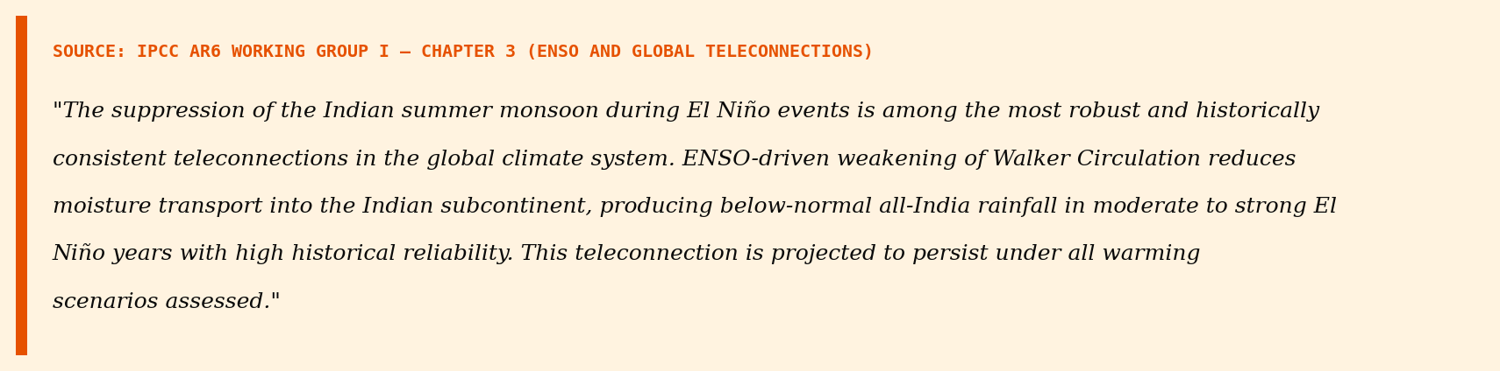
The chart below shows all-India monsoon rainfall departure from the long-period average from 2002 to 2023. El Niño years are highlighted in amber. The pattern is not ambiguous.
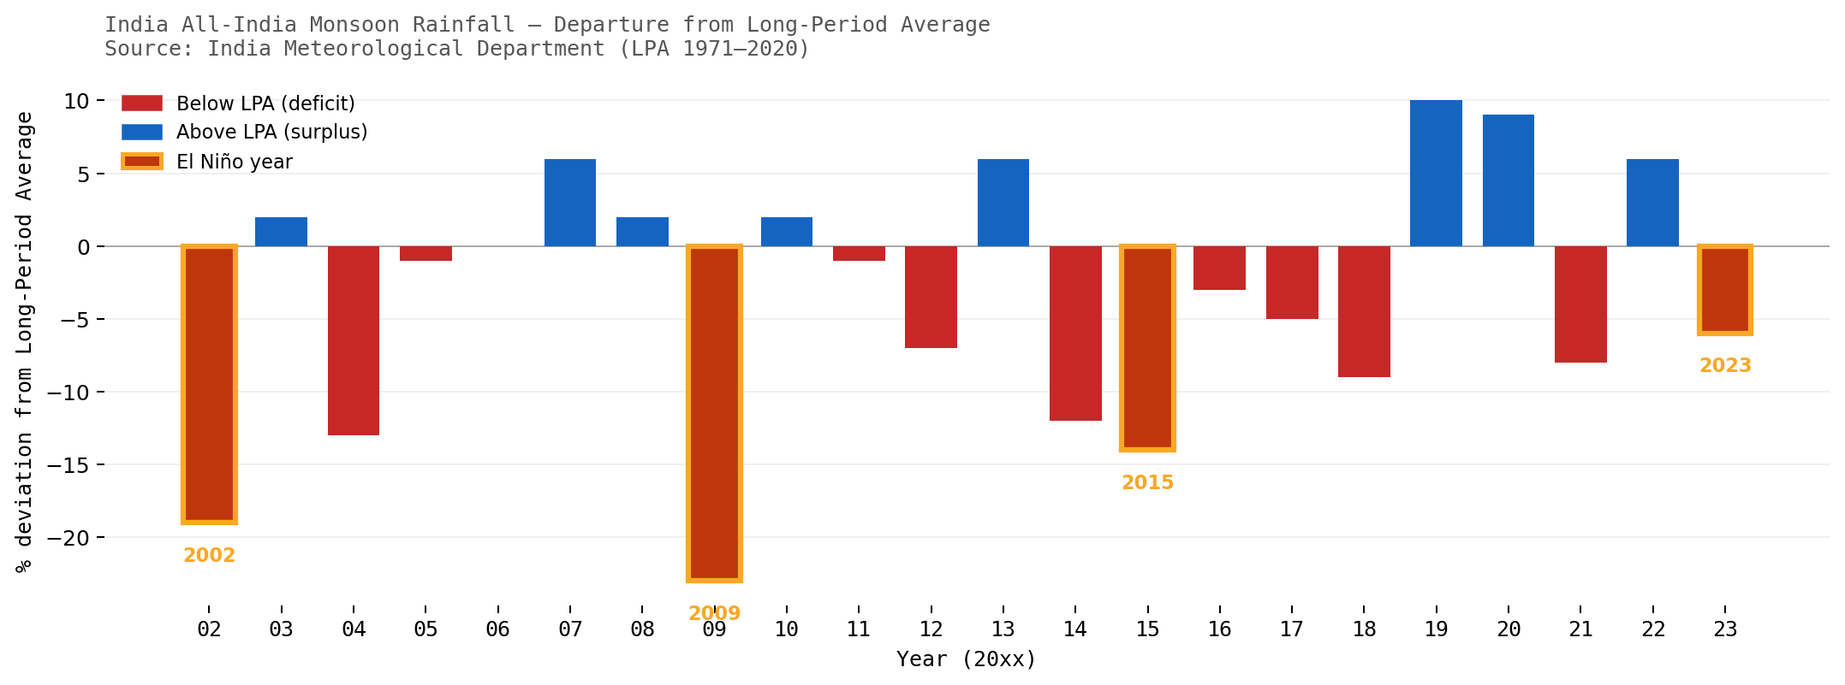
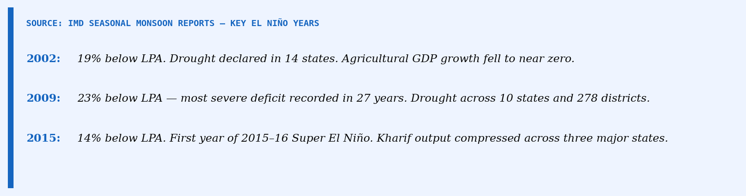

The 2023 Case: From SST Anomaly to Rice Price Spike
The 2023 to 2024 Super El Niño peaked at approximately +2.0°C above the 1991 to 2020 baseline in the Niño 3.4 region. [NOAA ENSO Monitoring] India's 2023 southwest monsoon was spatially uneven and below normal in several major kharif-producing states. [IMD Seasonal Report 2023] In July 2023, India imposed restrictions on non-basmati white rice exports. In August 2023 the restrictions widened. [Ministry of Commerce, India]
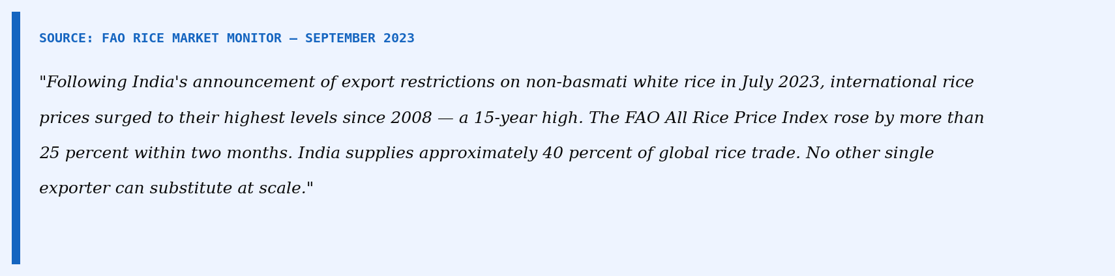
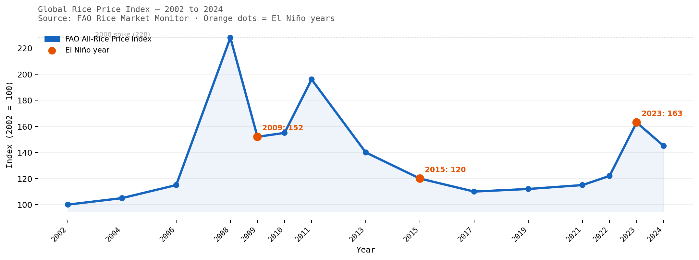
"India supplies 40 percent of global rice trade. When India partially exits the export market, the price signal reaches every food-importing country within weeks — from Bangladesh to Senegal."

Six Financial Transmission Pathways
The physical parameters do not stay in meteorology. A monsoon deficit moves through six channels into financial statements, credit portfolios, and sovereign balance sheets.
1. Agricultural Commodity Markets [FAO Rice Market Monitor]
Rice, sugar, cotton — direct supply disruption when the monsoon fails. Simultaneous across multiple crops in a single season.
2. Agricultural Credit Risk [RBI Financial Stability Report]
Gross NPA ratios in the agri segment of scheduled commercial banks rise 50–100 bps above trend in deficit years. Stress concentrated in rain-fed districts.
3. Sovereign Fiscal Stress [Ministry of Consumer Affairs, India]
Food Corporation of India draws buffer stocks or procures at higher MSP. 800M NFSA beneficiaries mean subsidy costs rise when production falls.
4. FMCG Corporate Earnings [Company filings — HUL, ITC, Dabur, Marico]
Rural India is 35–40% of FMCG revenues. Monsoon is the single largest variable cited in quarterly results — impact visible within 2 quarters.
5. Hydropower and Energy Substitution [Central Electricity Authority of India]
25% of India's electricity from hydro. A deficit year reduces reservoir levels, curtails generation, forces thermal substitution.
6. Emerging Market Contagion [IMF Global Financial Stability Report]
Food-importing sovereigns across Asia, Africa, and the Middle East face import cost spikes when India exits the rice market.
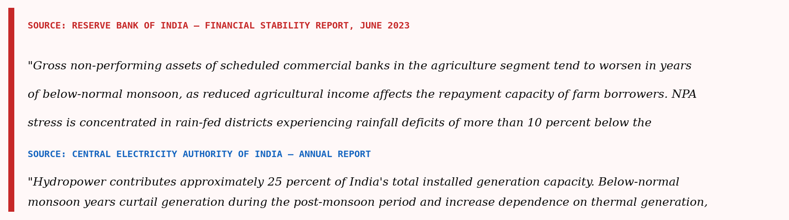

What Climate Science Says About the Monsoon Through 2050
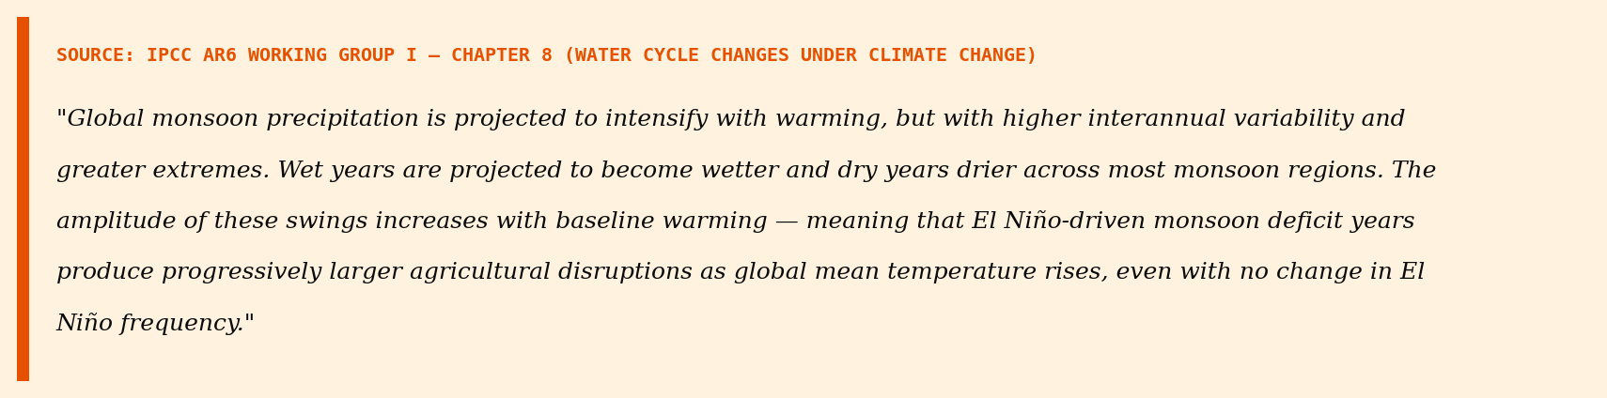
El Niño events are not projected to become more frequent. [IPCC AR6 WGI Ch.3] The ENSO cycle does not systematically accelerate under climate change. What changes is the baseline on which each event operates. A Niño 3.4 anomaly of +1.0°C in 2035 operates on an ocean already 0.3 to 0.4°C warmer than in 2009. The amplification comes not from more frequent events but from a warmer baseline beneath each one.
The NGFS Phase 4 scenarios translate this science into financial projections. [NGFS Phase 4 Documentation] The chart below shows the modelled agricultural EBITDA index for monsoon-exposed food and agri companies under three scenarios through 2050.
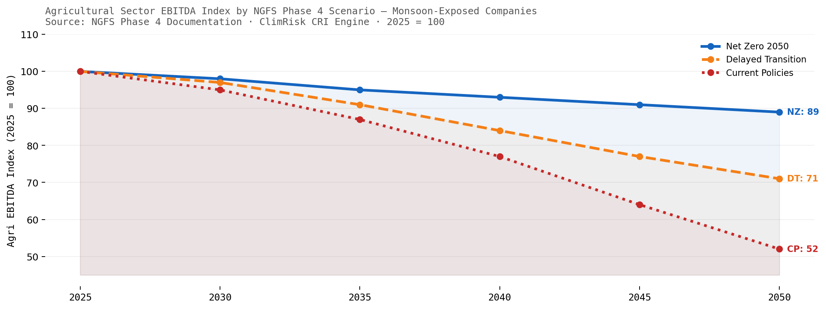
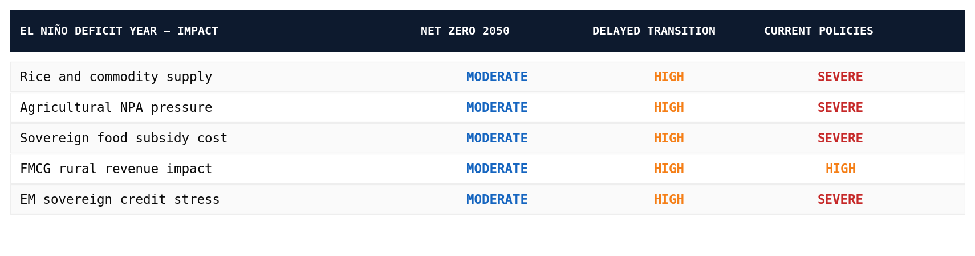

What This Means for Capital Allocation
Standard financial models do not price monsoon risk systematically. India equity research treats the monsoon as a one-line qualitative comment in FMCG and agri sector notes. Agricultural credit risk frameworks do not embed ENSO cycle probability distributions into NPA forecasting. Sovereign credit models do not connect monsoon deficit probability to fiscal stress estimates under different warming pathways.
The 2023 case makes this gap concrete. The physical cascade from Niño 3.4 SST anomaly to India rice export restriction to the FAO-recorded 15-year price high [FAO Rice Monitor, Sept 2023] was physically predictable months before it occurred. The Walker Circulation signal was visible in atmospheric data by April 2023. [IPCC AR6 WGI Ch.3] IMD's June 2023 forecast flagged uneven spatial distribution. [IMD Seasonal Forecast, June 2023] The financial consequences arrived in July. Markets priced them as a surprise.
"The physical signal was visible in April. The markets reacted in July. That gap — between observable atmospheric physics and financial pricing — is where the loss occurs."
The physical parameters are public. The IMD [IMD] publishes 150 years of rainfall data. The FAO [FAO] publishes monthly commodity price monitoring. The RBI [RBI FSR] publishes semi-annual financial stability assessments. The IPCC publishes the science. [IPCC AR6] What is missing is the analytical framework that connects the physical signal to the financial output — at the asset level, before the cascade completes rather than after.
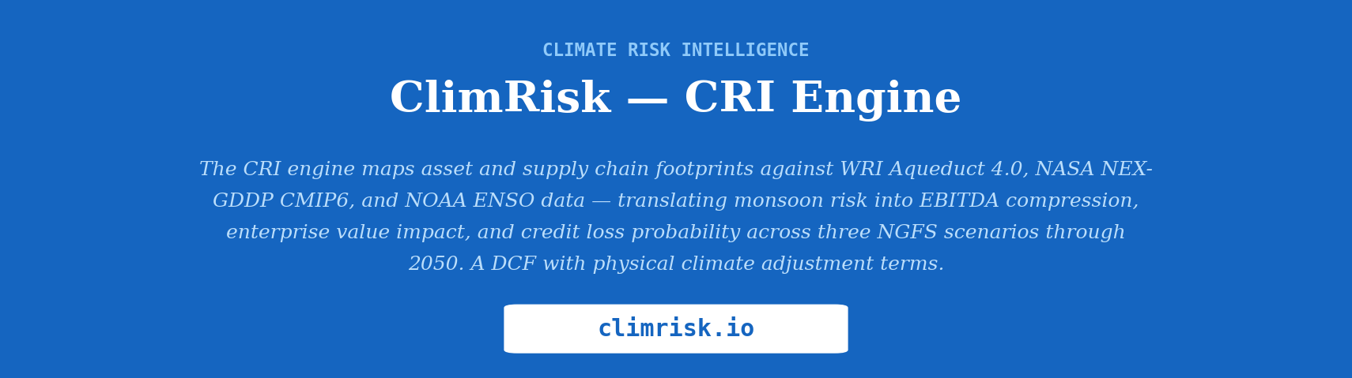
Data sources: India Meteorological Department · NOAA ENSO Monitoring Centre · FAO Rice Market Monitor (September 2023) · USDA Foreign Agricultural Service · Reserve Bank of India Financial Stability Reports (June 2022, June 2023) · Central Electricity Authority of India · IPCC AR6 Working Group I Chapters 3 and 8 · NGFS Phase 4 scenarios · IMF World Economic Outlook and Global Financial Stability Report
Shrinivash D Kannan — Founder, ClimRisk · climrisk.io

